Practical 1
Practicum:
- Identify the various parts of computer
Aim = The aim of this practical is to identify and study the various parts of a computer system. A computer consists of different parts such as the monitor, CPU, keyboard, mouse, speakers, printer, webcam, and microphone. Each part performs a specific function and helps the computer to work properly. By identifying these parts, we can understand their uses and basic functions.
Feature= A computer has several important features. It works at high speed and can perform many calculations in a short time. It provides accuracy in processing data and can store a large amount of information. A computer can perform different types of tasks, such as typing, calculating, drawing, browsing, and playing multimedia. It can also work continuously without getting tired and gives quick results.
- High Speed – Performs tasks very quickly.
- Accuracy – Produces accurate results.
- Storage – Stores a large amount of data.
- Versatility – Performs different types of tasks.
- Automation – Performs tasks automatically after instructions are given.
- Reliability – Gives consistent results.
- Diligence – Can work continuously without getting tired.
- Multitasking – Can perform multiple tasks at the same time.
- Various Parts of a Computer
  - Monitor – Displays information, pictures, and videos.
  - CPU – Processes data and controls computer operations.

  - Keyboard – Used to type text, numbers, and commands.
  - Mouse – Used to point, select, and click.
  - Speakers – Produce sound.
  - Printer – Prints documents and pictures on paper.
  - Microphone – Used to input sound.

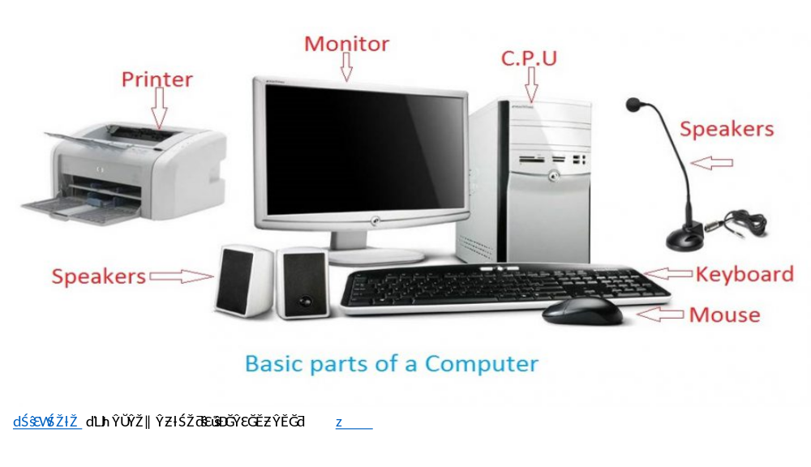

- Using computer/mobile software and hardware
- Aim
- To understand and develop basic skills in using computer and mobile hardware and software for performing everyday tasks such as creating documents, accessing the internet, communicating, and managing digital information.
- Features
  - Easy to use and user-friendly interface.
  - Supports communication through calls, messages, and email.
  - Allows internet browsing and access to online services.
  - Helps create, edit, save, and share documents.
  - Supports multimedia such as images, audio, and videos.
  - Provides data storage and file management.
  - Supports various software applications for education and work.
  - Enables connectivity through Wi-Fi, Bluetooth, and mobile networks.
- Computer/mobile hardware refers to the physical parts of a device, while software refers to the programs and applications that run on it.
  - Hardware: Keyboard, mouse, monitor, processor, memory, hard disk/SSD, printer, camera, microphone, touchscreen, and battery.
  - Software: Operating systems such as Windows, Android, and iOS, along with applications such as word processors, web browsers, email apps, and video-conferencing software.
  - Basic uses: Typing documents, browsing the internet, sending emails, making video calls, storing and sharing files, creating presentations, and using educational or workplace applications.
  - Safe use: Keep software updated, use strong passwords, install applications from trusted sources, back up important data, and avoid suspicious links or files.

- Use of operating system for various tasks such as file creation, directory creation, using control panel, etc.
Aim
To understand and perform various tasks using an operating system, such as creating and managing files and directories, using the Control Panel/Settings, and managing basic system functions.
Features
  - Creating, renaming, copying, moving, and deleting files.
  - Creating and managing directories (folders).
  - Searching for files and folders.
  - Managing drives and storage space.
  - Using Control Panel/Settings to configure system options.
  - Installing and uninstalling software.
  - Managing users, passwords, and system settings.
  - Changing display, keyboard, mouse, date, and time settings.
  - Managing printers and other connected devices.
  - Using security and update settings.

- Using Internet & various browsers.
- Aim
To understand the Internet and various web browsers, their basic functions, and how they are used to access information and online services.

Features
  - Provides access to information from websites worldwide.
  - Supports web browsing and online searching.
  - Allows users to send and receive emails. HRxkaptan@gmail.com
  - Supports downloading and uploading files.
  - Enables online shopping, banking, education, and entertainment.
  - Web browsers provide features such as tabs, bookmarks, history, and private browsing.
  - Common browsers include Google Chrome, Mozilla Firefox, Microsoft Edge, Safari, and Opera.
  - Provides security features such as HTTPS, password protection, and pop-up blocking.
If you mean “Using the Internet and various browsers” as a topic, it refers to accessing information and online services through web browsers such as Chrome, Firefox, Edge, Safari, and Opera.

- Internet: A global network used to access websites, online services, email, media, and other resources.
- Web browser: Software that lets you access and interact with websites.
- Common browsers: Google Chrome, Mozilla Firefox, Microsoft Edge, Apple Safari, and Opera.
- Uses: Searching for information, communicating, online learning, shopping, banking, entertainment, and downloading/uploading files.
- Safe browsing: Use strong passwords, keep browsers updated, check website addresses, avoid suspicious links/downloads, and be cautious when entering personal information.

- Identify the various hardware/software required for Internet.
Aim
To identify the various hardware and software required to access and use the Internet.
Hardware Required
- Computer/Laptop/Smartphone – Used to access the Internet.
- Modem – Connects the device/network to the Internet service.
- Router – Distributes the Internet connection to multiple devices.
- Network Interface Card (NIC) – Enables a computer to connect to a network.
- Ethernet Cable – Provides a wired network connection.
- Wi-Fi Adapter – Allows devices to connect wirelessly.
- Internet connection – Such as broadband, fiber, mobile data, or Wi-Fi.
Software Required
- Operating System – Windows, Linux, macOS, Android, or iOS.
- Web Browser – Chrome, Firefox, Edge, Safari, etc.
- Email Software/Service – Used to send and receive emails.
- Network Drivers – Help the operating system communicate with network hardware.
- Security Software – Antivirus and firewall software help protect the device while online.
Conclusion
Both hardware and software are necessary for accessing the Internet. Hardware provides the physical connection, while software enables users to communicate, browse websites, and use online services.

- How to create and use e-mail account
- Aim
To learn how to create and use an e-mail account for sending and receiving electronic messages over the Internet.
Steps to Create an E-mail Account
  - Open an e-mail service such as Gmail, Outlook, or Yahoo Mail.
  - Click on Create Account or Sign Up.
  - Enter your name and other required details.
  - Choose a unique username/e-mail address.
  - Create a strong password.
  - Enter your mobile number or recovery information if required.
  - Complete the verification process.
  - Accept the terms and conditions.
  - Your e-mail account is now ready to use.
How to Use an E-mail Account
  - Compose: Write and send a new e-mail.
  - To: Enter the recipient's e-mail address.
  - Subject: Write the topic of the e-mail.
  - Message: Type the required information.
  - Attachment: Add documents, images, or other files.
  - Send: Send the e-mail to the recipient.
  - Inbox: Read received e-mails.
  - Reply: Respond to an received e-mail.
  - Forward: Send a received e-mail to another person.
  - Delete: Remove unwanted e-mails.
  - Logout: Sign out after using the account, especially on shared computers.
Conclusion
An e-mail account allows users to send, receive, store, and manage electronic messages and files quickly through the Internet.

- Using Facebook, WhatsApp, Instagram, LinkedIn, Telegram
- Writing blogs

